БЕЛОРУССКИЙ ГОСУДАРСТВЕННЫЙ УНИВЕРСИТЕТ ИНФОРМАТИКИ И РАДИОЭЛЕКТРОНИКИ
Кафедра программного обеспечения информационных технологий

Факультет НиДО
Специальность ПОИТ

Индвидуальная практическая работа № 2.3
по дисциплине
«Программное обеспечение встроенных систем»

Выполнил: Старостин Н.А.

Минск, 2022

Задание
Напишите программу, которая отображает значение нажатой йнопки на 7- сегментном индикаторе.
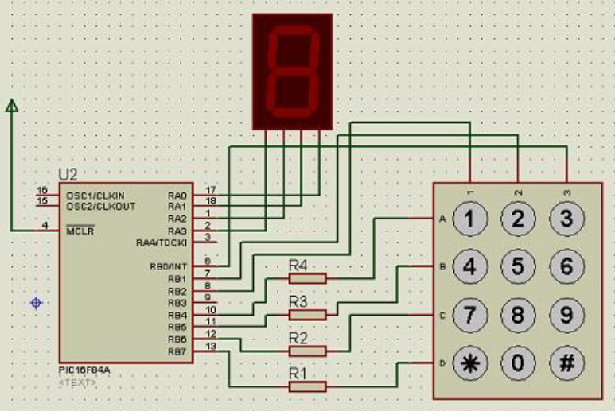

Решение
#include "p16f84a.inc"

w_temp equ 0x40
status_temp equ 0x41

delay1 equ 0x42
delay2 equ 0x43

result equ 0x30

readed equ 0x44
first_value equ 0x45
action equ 0x46
second_value equ 0x47
state equ 0x48
loop equ 0x49
is_action equ 0x4a
temp equ 0x4b
op_result equ 0x4c

__CONFIG _CP_OFF & _WDT_OFF & _PWRTE_ON & _RC_OSC

ORG 0x000
GOTO Start

ORG 0x004 ; interrupts
;save W state
MOVWF w_temp ; save off current W register contents
MOVF STATUS,0
MOVWF status_temp ; save off contents of STATUS register

BTFSS INTCON, RBIF ; check, is RB4-RB-7 bit port value changed
GOTO OTHER_INTERRUPT

MOVF PORTB, 0
ANDLW b'11111000'
IORLW b'00000011'
MOVWF PORTB

BTFSS PORTB, 4
MOVLW 1
BTFSS PORTB, 4
MOVWF result
BTFSS PORTB, 5
MOVLW 4
BTFSS PORTB, 5
MOVWF result
BTFSS PORTB, 6
MOVLW 7
BTFSS PORTB, 6
MOVWF result
BTFSS PORTB, 7
MOVLW 0x0A
BTFSS PORTB, 7
MOVWF result

MOVF PORTB, 0
ANDLW b'11111000'
IORLW b'00000101'
MOVWF PORTB

BTFSS PORTB, 4
MOVLW 2
BTFSS PORTB, 4
MOVWF result
BTFSS PORTB, 5
MOVLW 5
BTFSS PORTB, 5
MOVWF result
BTFSS PORTB, 6
MOVLW 8
BTFSS PORTB, 6
MOVWF result
BTFSS PORTB, 7
MOVLW 0
BTFSS PORTB, 7
MOVWF result

MOVF PORTB, 0
ANDLW b'11111000'
IORLW b'00000110'
MOVWF PORTB

BTFSS PORTB, 4
MOVLW 3
BTFSS PORTB, 4
MOVWF result
BTFSS PORTB, 5
MOVLW 6
BTFSS PORTB, 5
MOVWF result
BTFSS PORTB, 6
MOVLW 9
BTFSS PORTB, 6
MOVWF result
BTFSS PORTB, 7
MOVLW 0x0B
BTFSS PORTB, 7
MOVWF result

MOVF PORTB, 0
ANDLW b'11111000'
MOVWF PORTB

BTFSC readed, 0
GOTO REPEATING_READ

MOVF state, 0
SUBLW 4
BTFSC STATUS, Z
GOTO FIRST_NUMBER
MOVF state, 0
SUBLW 0
BTFSC STATUS, Z
GOTO FIRST_NUMBER
MOVF state, 0
SUBLW 1
BTFSC STATUS, Z
GOTO FIRST_NUMBER
MOVF state, 0
SUBLW 2
BTFSC STATUS, Z
GOTO SECOND_NUMBER
MOVF state, 0
SUBLW 3
BTFSC STATUS, Z
GOTO ACTION_DOING
GOTO FINISH_PROCESSING
ACTION_DOING:
MOVF result, 0
MOVWF second_value
CALL CHECK_STATE
BTFSC is_action, 0
GOTO SECOND_NUMBER
BTFSC action, 0
GOTO REALIZE_MULTIPLY
MOVF first_value, 0
ADDWF result, 1
GOTO POST_ACTION
REALIZE_MULTIPLY:
CLRF result
CLRF loop
MULTIPLY_LOOP:
MOVF second_value, 0
SUBWF loop, 0
BTFSC STATUS, 2 ; stop, if result is zero
GOTO POST_ACTION
MOVF result, 0
ADDWF first_value, 0
MOVWF result
INCF loop, 1
GOTO MULTIPLY_LOOP
POST_ACTION:
MOVLW 1
MOVWF state
MOVF result, 0
MOVWF op_result
CLRF first_value
CLRF action
CLRF second_value
FIRST_NUMBER:
MOVF result, 0
MOVWF first_value
CALL CHECK_STATE
BTFSC is_action, 0
GOTO FINISH_PROCESSING
MOVLW 2
MOVWF state
GOTO FINISH_PROCESSING
SECOND_NUMBER:
MOVF result, 0
SUBLW 0x0A
BTFSC STATUS, Z
GOTO MULTIPLY
MOVF result, 0
SUBLW 0x0B
BTFSC STATUS, Z
GOTO PLUS
MOVLW 1
MOVWF state
GOTO FINISH_PROCESSING
PLUS:
BSF action, 1
MOVLW 3
MOVWF state
GOTO FINISH_PROCESSING
MULTIPLY:
BSF action, 0
MOVLW 3
MOVWF state
GOTO FINISH_PROCESSING
REPEATING_READ:
;MOVF state, 0
;SUBLW 3
;BTFSC STATUS, Z
;GOTO FINISH_PROCESSING
;MOVF op_result, 0
;MOVWF result
FINISH_PROCESSING:
BSF readed, 0
MOVF PORTA, 0
ANDLW b'11110000';
IORWF result, 0
MOVWF PORTA
BCF INTCON, RBIF
CALL DELAY
OTHER_INTERRUPT:
;restore W state
MOVF status_temp, 0 ; retrieve copy of STATUS register
MOVWF STATUS ; restore pre-isr STATUS register contents
SWAPF w_temp, 1
SWAPF w_temp, 0 ; restore pre-isr W register contents
RETFIE ; return from interrupt

DELAY:
BCF STATUS, RP0 ; Bank 0
MOVLW 0x10
MOVWF delay1
MOVLW 0x10
MOVWF delay2
DELAY_LOOP_START:
DECFSZ delay1, 1
GOTO DELAY_LOOP_ADDITIONAL
DECFSZ delay2, 1
DELAY_LOOP_ADDITIONAL:
GOTO DELAY_LOOP_START
RETURN

CHECK_STATE:
MOVF result, 0
MOVWF temp
CLRF is_action
MOVF result, 0
SUBLW 0x0A
BTFSC STATUS, Z
BSF is_action, 0
SUBLW 1
BTFSC STATUS, Z
BSF is_action, 0
BTFSC is_action, 0
MOVLW 1
BTFSC is_action, 0
MOVWF state
MOVF temp, 0
MOVWF result
RETURN

; ========================================
; PROGRAM START
; ========================================

Start:
;initializing ports
BCF STATUS, RP0 ; Bank 0
MOVLW b'00000000';
MOVWF PORTB ; Initializing PORTB
CLRF PORTA ; Initializing PORTA
BSF STATUS, RP0 ; Bank 1
MOVLW b'11110000' ; bit value for TRISB state
MOVWF TRISB
CLRF TRISA
BCF OPTION_REG, 7

BCF STATUS, RP0 ; Bank 0

CLRF readed
CLRF state

BCF INTCON, RBIF ; clear interrupt value for RB4-7
BSF INTCON, RBIE ; allow interrupts on RB4-7
BSF INTCON, GIE ; enable interrupts
CLRF state

Loop:
SLEEP
CLRF readed
GOTO Loop
END
; ========================================
; PROGRAM END
; ========================================

